**ALL IN ONE CONVERTOR**

**A** **Project** **Work** **Report**

*Submitted* *in* *the* *partial* *fulfilment* *for* *the* *award* *of* *the* *degree* *of*

**BACHELOR** **OF** E**NGINEERING**

**IN**

COMPUTER SCIENCE

BIG DATA ANALYTICS

**Submitted** **by:**

**DIGVIJAY KUMAR**

**AVINASH RAJ**

**19BCS3878**

**19BCS3899**

**Under** **the** **Supervision** **of:**

**JYOTI MEHRA**

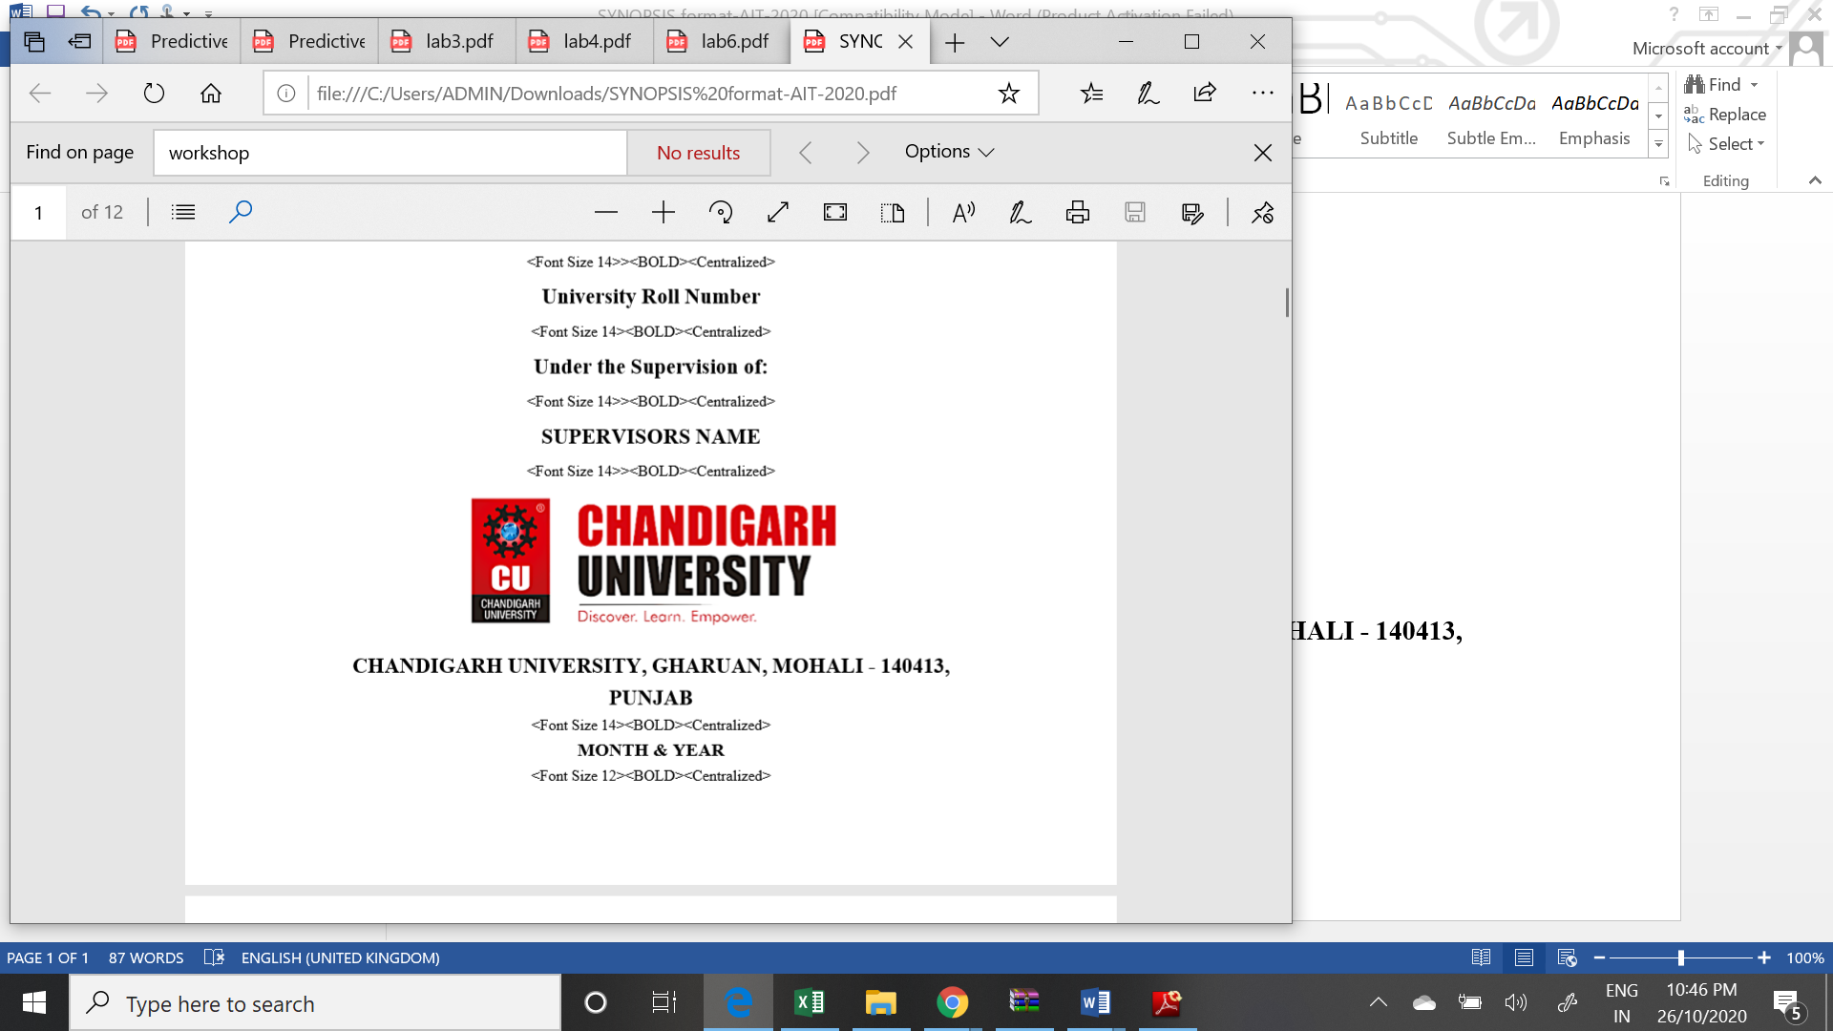

**CHANDIGARH** **UNIVERSITY,** **GHARUAN,** **MOHALI** **-** **140413,** **PUNJAB**

**December, 2020**

Name and signature of student(s)

Name and signature of Supervisor

# 

# 

# PROJECT COMPLETION CERTIFICATE

## Project Title

This is to certify that the DIGVIJAY KUMAR AND AVINASH RAJ have successfully completed the project work titled “ ALL IN ONE CONVERTOR ” *Submitted* *in* *the* *partial* *fulfilment* *for* *the* *award* *of* *the* *degree of* **BACHELOR** **OF** E**NGINEERING** **IN COMPUTER SCIENCE BIG DATA ANALYTICS**

This project is the record of authentic work carried out during the academic year.

JYOTI MEHRA

Project Guide

**Date: 5 DEC 2020**

# DECLARATION

I the undersigned solemnly declare that the project report is based on my own work carried out during the course of our study under the supervision of jyoti mehra. I assert the statements made and conclusions drawn are an outcome of my work. I further certify that the work contained in the report is original and has been done by me under the general supervision of my supervisor.

II. The work has not been submitted to any other Institution for any other degree/diploma/certificate in this university or any other University of India or abroad.

III. We have followed the guidelines provided by the university in writing the report.

IV. Whenever we have used materials (data, theoretical analysis, and text) from other sources, we have given due credit to them in the text of the report and giving their details in the references.

NAME - DIGVIJAY KUMAR

AVINASH RAJ

UID - 19BCS3878

19BCS3899

# ACKNOWLEDGEMENT

I have taken efforts in this project. However, it would not have been possible without the kind support and help of many individuals and organizations. I would like to extend my sincere thanks to all of them.

I am highly indebted to (Name of your Organization Guide) for their guidance and constant supervision as well as for providing necessary information regarding the project & also for their support in completing the project.

I would like to express my gratitude towards my parents and my department for their kind co-operation and encouragement which help me in completion of this project.

THANKS AGAIN TO ALL WHO HELPED

Chapter 1: Introduction to project

Chapter 2: Project Requirements (Software/Hardware requirements)

Chapter 3: Implementation Details (Algorithm, code )

Chapter 4: Output Analysis (screenshots)

**Introduction to project**

This is a all in one convertor in which you can convert different different parameters like speed, power, pressure, volume, weight, area, length, temperature.

We developed this project using python language, however the project is a GUI application that convert different quantities.

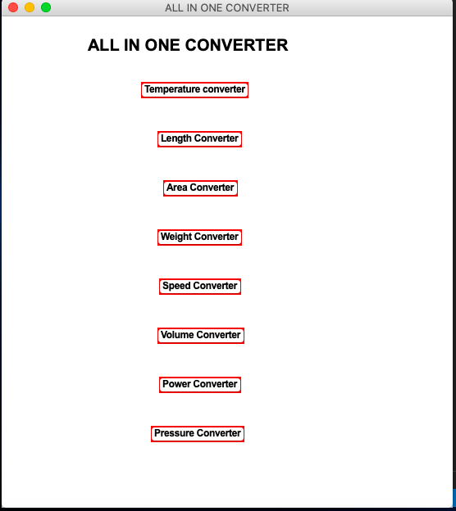

**Project Requirements (Software/Hardware requirements)**

Software

1. Operating system - window 7 or above

Mac OS X or above

Linux

2. IDE ( working station) - VS code

Sublime

Pycharm

Spyder

Hardware

For Mac - work in all MacBook

For window - Intel pentium 4 or above

700 MB of harddisk drive

256 MB of RAM

**Implementation Details (Algorithm, code )**

**ALGORITHM**

**Step0 : start a function named speed convertor.**

**Step1 : set IDS for each measurement types.**

**Step2 : write a function named “CONVERT” with parameters “amount”, “from”, “to”.**

**Step3 : inside function if frm! “meps”**

**SET amt = amt*factors[frm]**

**Return amt/factors[to]**

**[END of the function]**

**Step4 : [END of the main function]**

**Step5 : start a function named power convertor.**

**Step6 : set IDS for each measurement types.**

**Step7 : write a function named “CONVERT” with parameters “amount”, “from”, “to”.**

**Step8 : inside function if frm! = “W”**

**SET amt = amt*factor[frm]**

**Return amt/factors[to]**

**Else return amt/factors[to]**

**[END of the function].**

**Step9 : [END of the main function].**

**Step10 : start a function named pressure convertor.**

**Step11 : set IDS for each measurement types.**

**Step12 : write a function named “CONVERT” with parameters “amount”, “from”, “to”.**

**Step13 : iside function if frm! = “W”**

**SET amt = amt*factor[frm]**

**Return amt/factors[to]**

**Else return amt/factors[to]**

**[END of the function].**

**Step14 : [END of the main function].**

**Step15 : start a function named pressure convertor.**

**Step16 : set IDS for each measurement types.**

**Step17 : write a function named “CONVERT” with parameters “amount”, “from”, “to”.**

**Step18 : inside function if frm! = “1”**

**SET amt = amt*factor[frm]**

**Return amt/factor[to]**

**Else return amt/factors[to]**

**[END of the function].**

**Step19 : [END of the main function].**

**STEP20 : start a function named weight convertor.**

**Step21 : set IDS for each measurement types.**

**Step22 : write a function named “CONVERT” with parameters “amount”, “from”, “to”.**

**Step23 : inside function if frm! = ‘g’**

**SET amt = amt*factors[frm]**

**Return amt/factors[to]**

**Else return amt/factors[to]**

**[END of the function].**

**Step24 : [END of the main function].**

**STEP25 : start a function named area convertor.**

**Step26 : set IDS for each measurement types.**

**Step27 : write a function named “CONVERT” with parameters “amount”, “from”, “to”.**

**Step28 : inside function if fromvar.get() present in meter factor.keys() and to var.get() present in meter factor.keys().**

**Step29 : result = (float(str(x))*meter factor [from unit] / (meter function [to unit])**

**resultxt.insert (0, str(result))**

**[END of the function].**

**Step30 : [END of the main function].**

**STEP31 : start a function named length convertor.**

**Step32 : set IDS for each measurement types.**

**Step33 : write a function named “CONVERT” with parameters “amount”, “from”, “to”.**

**Step34 : inside function if frm! = ‘m’**

**SET amt = amt*factor[frm]**

**Return amt/factors[to]**

**Else return amt/factors[to]**

**[END of the function].**

**Step35 : [END of the main function].**

**STEP36 : start a function named temperature convertor.**

**Step37 : set IDS for each measurement types.**

**Step38 : write a function named “CONVERT” with parameters “amount”, “from”, “to”.**

**Step39 : inside function if celTempvar.get()! = 0.0**

**celToFah = (celTemp*9/5 + 32)**

**fahTempvar.set(celToFah)**

**Elif fahTempvar.get()! = 0.0**

**fahToCel = ((fahTemp - 32)*(5/9))**

**celTempvar.set(fahToCel)**

**[END of the function].**

**Step40 : [END of the main function].**

**CODE**

**import** sys

**import** tkinter **as** tk

**from** tkinter **import** *

**import** urllib.request

**import** webbrowser

**from** functools **import** partial

**from** tkinter **import** Tk, StringVar , ttk

*#################################### MAIN ############################################*

root = Tk()

root.title('ALL IN ONE CONVERTER')

root.geometry("550x600+200+300")

labelfont = ('ariel', 56, 'bold')

l=Label(root,text='ALL IN ONE CONVERTER',font = ("Arial", 20, "bold"), justify = CENTER)

l.place(x=100,y=20)

*######################################################################################*

*############################################### SPEED CONVERTER START ########################################################################*

**def** SpeedConverter():

factors = {'kmph' : 0.2777777778, 'mph' : 0.44704, 'meph' : 0.0002777778, 'mps' : 1609.344 ,'kmps' : 1000, 'meps' : 1}

ids = {"km/hour" : 'kmph', "mile/hour" : 'mph', "meter/hour" : 'meph', "mile/second" : 'mps', "km/second" : 'kmps'}

*# function to convert from a given unit to another*

**def** convert(amt, frm, to):

**if** frm != 'meps':

amt = amt * factors[frm]

**return** amt / factors[to]

**else**:

**return** amt / factors[to]

**def** callback():

**try**:

amt = float(in_field.get())

**except** ValueError:

out_amt.set('Invalid input')

**return** **None**

**if** in_unit.get() == 'Select Unit' **or** out_unit.get() == 'Select Unit':

out_amt.set('Input or output unit not chosen')

**return** **None**

**else**:

frm = ids[in_unit.get()]

to = ids[out_unit.get()]

out_amt.set(convert(amt, frm, to))

*# initiate window*

root = Toplevel()

root.title("Speed Converter")

*# initiate frame*

mainframe = ttk.Frame(root, padding="3 3 12 12")

mainframe.pack(fill=BOTH, expand=1)

titleLabel = Label (mainframe, text = "Speed Converter", font = ("Arial", 12, "bold"), justify = CENTER).grid(column=1,row=1)

in_amt = StringVar()

in_amt.set('0')

out_amt = StringVar()

in_unit = StringVar()

out_unit = StringVar()

in_unit.set('Select Unit')

out_unit.set('Select Unit')

*# Add input field*

in_field = ttk.Entry(mainframe, width=20, textvariable=in_amt)

in_field.grid(row=1, column=2, sticky=(W, E))

*# Add drop-down for input unit*

in_select = OptionMenu(mainframe, in_unit, "km/hour", "mile/hour", "meter/hour", "mile/second","km/second") .grid(column=3, row=1, sticky=W)

*# Add output field and drop-down*

ttk.Entry(mainframe, textvariable=out_amt, state="readonly").grid(column=2, row=3, sticky=(W, E))

in_select = OptionMenu(mainframe, out_unit, "km/hour", "mile/hour", "meter/hour", "mile/second","km/second").grid(column=3, row=3, sticky=W)

calc_button = ttk.Button(mainframe, text="Calculate", command=callback).grid(column=2, row=2, sticky=E)

**for** child **in** mainframe.winfo_children(): child.grid_configure(padx=5, pady=5)

in_field.focus()

*############################################### SPEED CONVERTER END########################################################################*

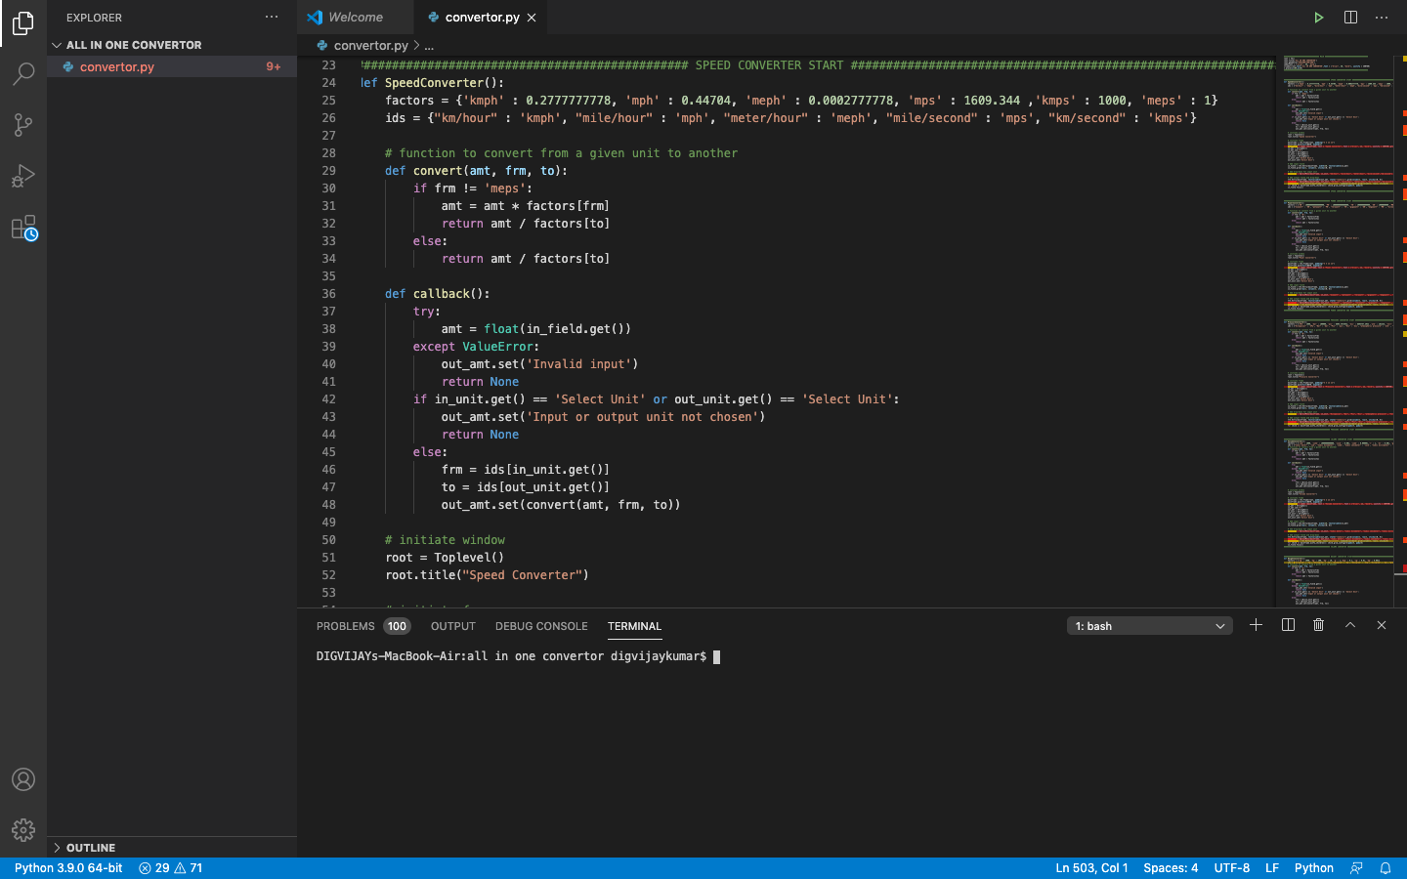

*############################################### POWWR CONVERTER START ########################################################################*

**def** PowerConverter():

factors = {'EW' : 1000000000000000000, 'PW' : 1000000000000000, 'TW' : 1000000000000, 'GW' : 1000000000 ,'MW' : 1000000, 'KW' : 1000 , 'HP' : 746 , 'W' : 1}

ids = {"exawatt" : 'EW', "petawatt" : 'PW', "terawatt" : 'TW', "gigawatt" : 'GW', "megawatt" : 'MW' , "kilowatt" : 'KW' , "horsepower" : 'HP' , "watt" : 'W'}

*# function to convert from a given unit to another*

**def** convert(amt, frm, to):

**if** frm != 'W':

amt = amt * factors[frm]

**return** amt / factors[to]

**else**:

**return** amt / factors[to]

**def** callback():

**try**:

amt = float(in_field.get())

**except** ValueError:

out_amt.set('Invalid input')

**return** **None**

**if** in_unit.get() == 'Select Unit' **or** out_unit.get() == 'Select Unit':

out_amt.set('Input or output unit not chosen')

**return** **None**

**else**:

frm = ids[in_unit.get()]

to = ids[out_unit.get()]

out_amt.set(convert(amt, frm, to))

*# initiate window*

root = Toplevel()

root.title("Power Converter")

*# initiate frame*

mainframe = ttk.Frame(root, padding="3 3 12 12")

mainframe.pack(fill=BOTH, expand=1)

titleLabel = Label (mainframe, text = "Power Converter", font = ("Arial", 12, "bold"), justify = CENTER).grid(column=1,row=1)

in_amt = StringVar()

in_amt.set('0')

out_amt = StringVar()

in_unit = StringVar()

out_unit = StringVar()

in_unit.set('Select Unit')

out_unit.set('Select Unit')

*# Add input field*

in_field = ttk.Entry(mainframe, width=20, textvariable=in_amt)

in_field.grid(row=1, column=2, sticky=(W, E))

*# Add drop-down for input unit*

in_select = OptionMenu(mainframe, in_unit, "exawatt" , "petawatt" , "terawatt" , "gigawatt" , "megawatt" , "kilowatt", "horsepower" , "watt") .grid(column=3, row=1, sticky=W)

*# Add output field and drop-down*

ttk.Entry(mainframe, textvariable=out_amt, state="readonly").grid(column=2, row=3, sticky=(W, E))

in_select = OptionMenu(mainframe, out_unit, "exawatt" , "petawatt" , "terawatt" , "gigawatt" , "megawatt" , "kilowatt", "horsepower" , "watt").grid(column=3, row=3, sticky=W)

calc_button = ttk.Button(mainframe, text="Calculate", command=callback).grid(column=2, row=2, sticky=E)

**for** child **in** mainframe.winfo_children(): child.grid_configure(padx=5, pady=5)

in_field.focus()

*############################################### POWER CONVERTER END ########################################################################*

*############################################### PRESSURE CONVERTER START ########################################################################*

**def** PressureConverter():

factors = {'kPa' : 1000, 'bar' : 100000, 'psi' : 6894.7572932, 'ksi' : 6894757.2932 ,'atm' : 101325, 'torr' : 133.32236842 , 'Pa' :1}

ids = {"Kilopascal" : 'kPa', "Bar" : 'bar', "Psi" : 'psi', "Ksi" : 'ksi', "atmospheric pressure" : 'atm' , "Torr" : 'torr' ,"Pascal" : 'Pa'}

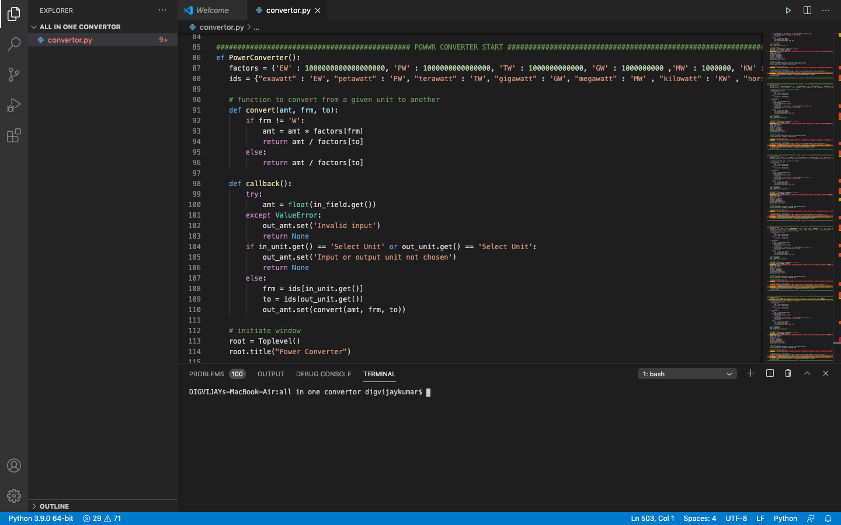

*# function to convert from a given unit to another*

**def** convert(amt, frm, to):

**if** frm != 'W':

amt = amt * factors[frm]

**return** amt / factors[to]

**else**:

**return** amt / factors[to]

**def** callback():

**try**:

amt = float(in_field.get())

**except** ValueError:

out_amt.set('Invalid input')

**return** **None**

**if** in_unit.get() == 'Select Unit' **or** out_unit.get() == 'Select Unit':

out_amt.set('Input or output unit not chosen')

**return** **None**

**else**:

frm = ids[in_unit.get()]

to = ids[out_unit.get()]

out_amt.set(convert(amt, frm, to))

*# initiate window*

root = Toplevel()

root.title("Pressure Converter")

*# initiate frame*

mainframe = ttk.Frame(root, padding="3 3 12 12")

mainframe.pack(fill=BOTH, expand=1)

titleLabel = Label (mainframe, text = "Pressure Converter", font = ("Arial", 12, "bold"), justify = CENTER).grid(column=1,row=1)

in_amt = StringVar()

in_amt.set('0')

out_amt = StringVar()

in_unit = StringVar()

out_unit = StringVar()

in_unit.set('Select Unit')

out_unit.set('Select Unit')

*# Add input field*

in_field = ttk.Entry(mainframe, width=20, textvariable=in_amt)

in_field.grid(row=1, column=2, sticky=(W, E))

*# Add drop-down for input unit*

in_select = OptionMenu(mainframe, in_unit, "Kilopascal", "Bar", "Psi", "Ksi" , "atmospheric pressure" , "Torr" ,"Pascal") .grid(column=3, row=1, sticky=W)

*# Add output field and drop-down*

ttk.Entry(mainframe, textvariable=out_amt, state="readonly").grid(column=2, row=3, sticky=(W, E))

in_select = OptionMenu(mainframe, out_unit, "Kilopascal", "Bar", "Psi", "Ksi" , "atmospheric pressure" , "Torr" ,"Pascal").grid(column=3, row=3, sticky=W)

calc_button = ttk.Button(mainframe, text="Calculate", command=callback).grid(column=2, row=2, sticky=E)

**for** child **in** mainframe.winfo_children(): child.grid_configure(padx=5, pady=5)

*############################################### PRESSURE CONVERTER START ########################################################################*

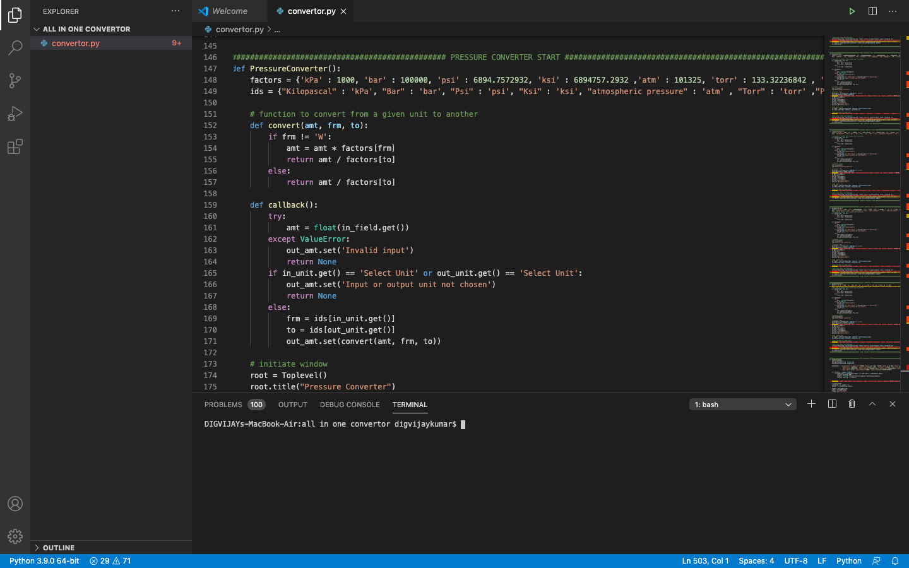

*############################################### vOLUME CONVERTER START ########################################################################*

**def** VolumeConverter():

factors = {'cum' : 1000, 'cukm' : 1000000000000, 'cucm' : 0.001, 'cumm' : 0.000001,'l' : 1, 'ml' : 0.001, 'gal' : 3.785411784}

ids = {"Cubic meter" : 'cum', "Cubic kilometer" : 'cukm', "Cubic cenimeter" : 'cucm', "Cubic millimeter" : 'cumm', "Liter" : 'l', "Milliliter" : 'ml', "gallon" : 'gal'}

*# function to convert from a given unit to another*

**def** convert(amt, frm, to):

**if** frm != 'l':

amt = amt * factors[frm]

**return** amt / factors[to]

**else**:

**return** amt / factors[to]

**def** callback():

**try**:

amt = float(in_field.get())

**except** ValueError:

out_amt.set('Invalid input')

**return** **None**

**if** in_unit.get() == 'Select Unit' **or** out_unit.get() == 'Select Unit':

out_amt.set('Input or output unit not chosen')

**return** **None**

**else**:

frm = ids[in_unit.get()]

to = ids[out_unit.get()]

out_amt.set(convert(amt, frm, to))

*# initiate window*

root = Toplevel()

root.title("Volume Converter")

*# initiate frame*

mainframe = ttk.Frame(root, padding="3 3 12 12")

mainframe.pack(fill=BOTH, expand=1)

titleLabel = Label (mainframe, text = "Volume Converter", font = ("Arial", 12, "bold"), justify = CENTER).grid(column=1,row=1)

in_amt = StringVar()

in_amt.set('0')

out_amt = StringVar()

in_unit = StringVar()

out_unit = StringVar()

in_unit.set('Select Unit')

out_unit.set('Select Unit')

*# Add input field*

in_field = ttk.Entry(mainframe, width=20, textvariable=in_amt)

in_field.grid(row=1, column=2, sticky=(W, E))

*# Add drop-down for input unit*

in_select = OptionMenu(mainframe, in_unit, "Cubic meter", "Cubic kilometer", "Cubic cenimeter", "Cubic millimeter", "Liter", "Milliliter", "gallon") .grid(column=3, row=1, sticky=W)

*# Add output field and drop-down*

ttk.Entry(mainframe, textvariable=out_amt, state="readonly").grid(column=2, row=3, sticky=(W, E))

in_select = OptionMenu(mainframe, out_unit, "Cubic meter", "Cubic kilometer", "Cubic cenimeter", "Cubic millimeter", "Liter", "Milliliter", "gallon").grid(column=3, row=3, sticky=W)

calc_button = ttk.Button(mainframe, text="Calculate", command=callback).grid(column=2, row=2, sticky=E)

**for** child **in** mainframe.winfo_children(): child.grid_configure(padx=5, pady=5)

in_field.focus()

*############################################### VOLUME CONVERTER END########################################################################*

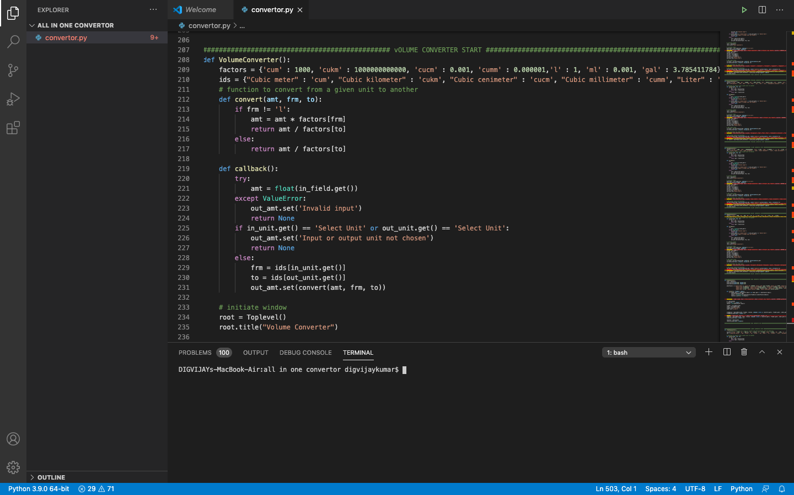

*############################################### WEIGHT CONVERTER START########################################################################*

**def** WeightConverter():

factors = {'kg' : 1000, 'hg' : 100, 'dg' : 10, 'g' : 1,'deg' : 0.1, 'cg' : 0.01, 'mg' : 0.001}

ids = {"Kilogram" : 'kg', "Hectagram" : 'hg', "Decagram" : 'dg', "Decigram" : 'deg', "Kilogram" : 'kg', "gram" : 'g', "centigram" : 'cg', "milligram" : 'mg'}

*# function to convert from a given unit to another*

**def** convert(amt, frm, to):

**if** frm != 'g':

amt = amt * factors[frm]

**return** amt / factors[to]

**else**:

**return** amt / factors[to]

**def** callback():

**try**:

amt = float(in_field.get())

**except** ValueError:

out_amt.set('Invalid input')

**return** **None**

**if** in_unit.get() == 'Select Unit' **or** out_unit.get() == 'Select Unit':

out_amt.set('Input or output unit not chosen')

**return** **None**

**else**:

frm = ids[in_unit.get()]

to = ids[out_unit.get()]

out_amt.set(convert(amt, frm, to))

*# initiate window*

root = Toplevel()

root.title("Weight Converter")

*# initiate frame*

mainframe = ttk.Frame(root, padding="3 3 12 12")

mainframe.pack(fill=BOTH, expand=1)

titleLabel = Label (mainframe, text = "Weight Converter", font = ("Arial", 12, "bold"), justify = CENTER).grid(column=1,row=1)

in_amt = StringVar()

in_amt.set('0')

out_amt = StringVar()

in_unit = StringVar()

out_unit = StringVar()

in_unit.set('Select Unit')

out_unit.set('Select Unit')

*# Add input field*

in_field = ttk.Entry(mainframe, width=20, textvariable=in_amt)

in_field.grid(row=1, column=2, sticky=(W, E))

*# Add drop-down for input unit*

in_select = OptionMenu(mainframe, in_unit, "Kilogram","Hectagram","Decagram", "gram", "Decigram","Centigram", "Milligram") .grid(column=3, row=1, sticky=W)

*# Add output field and drop-down*

ttk.Entry(mainframe, textvariable=out_amt, state="readonly").grid(column=2, row=3, sticky=(W, E))

in_select = OptionMenu(mainframe, out_unit, "Kilogram","Hectagram","Decagram", "gram", "Decigram","Centigram", "Milligram").grid(column=3, row=3, sticky=W)

calc_button = ttk.Button(mainframe, text="Calculate", command=callback).grid(column=2, row=2, sticky=E)

**for** child **in** mainframe.winfo_children(): child.grid_configure(padx=5, pady=5)

in_field.focus()

*############################################### WEIGHT CONVERTER END########################################################################*

*############################################### AREA CONVERTER START########################################################################*

**def** AreaConverter():

wind = Toplevel()

wind.minsize(width=400, height=150)

wind.maxsize(width=400, height=150)

meterFactor = {'square meter':1,'square km':1000000,'square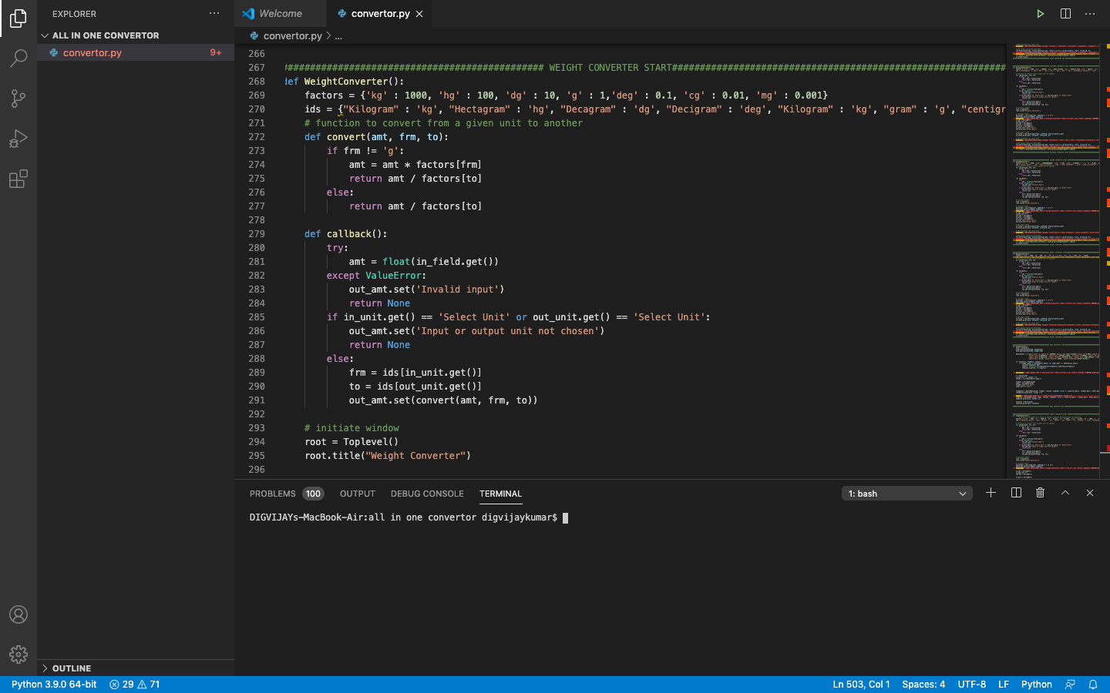 rood':1011.7141056,'square cm':0.0001,'square foot':0.09290304 ,

'square inch':0.00064516, 'square mile':2589988.110336, 'milimeter':0.000001,'square rod':25.29285264,

'square yard':0.83612736, 'square township':93239571.9721, 'square acre':4046.8564224 ,'square are': 100,

'square barn':1e-28, 'square hectare':10000, 'square homestead':647497.027584 }

**def** convert(x, fromUnit, toUnit):

**if** fromVar.get() **in** meterFactor.keys() **and** toVar.get() **in** meterFactor.keys():

resultxt.delete(0, END)

result = (float(str(x))*meterFactor[fromUnit])/(meterFactor[toUnit])

resultxt.insert(0, str(result))

titleLabel = Label (wind, text = "Area Converter", font = ("Arial", 12, "bold"), justify = CENTER).grid(column=1,row=1)

e = Entry(wind)

e.grid(row = 1, column = 2)

values = list(meterFactor.keys())

fromVar = StringVar(wind)

toVar = StringVar(wind)

fromVar.set("From Unit")

toVar.set("To Unit")

fromOption = OptionMenu(wind, fromVar, *values, command= **lambda** y: convert(e.get(), fromVar.get() ,toVar.get()))

fromOption.grid(row=1, column = 3)

toLabel = Label(wind, text="To : ", font="Arial").grid(row=2, column = 2)

toOption = OptionMenu(wind, toVar, *values, command= **lambda** x: convert(e.get(), fromVar.get() ,toVar.get()))

toOption.grid(row=3, column = 3)

resultxt = Entry(wind)

resultxt.grid(row=3, column=2)

*############################################### AREA CONVERTER END ########################################################################*

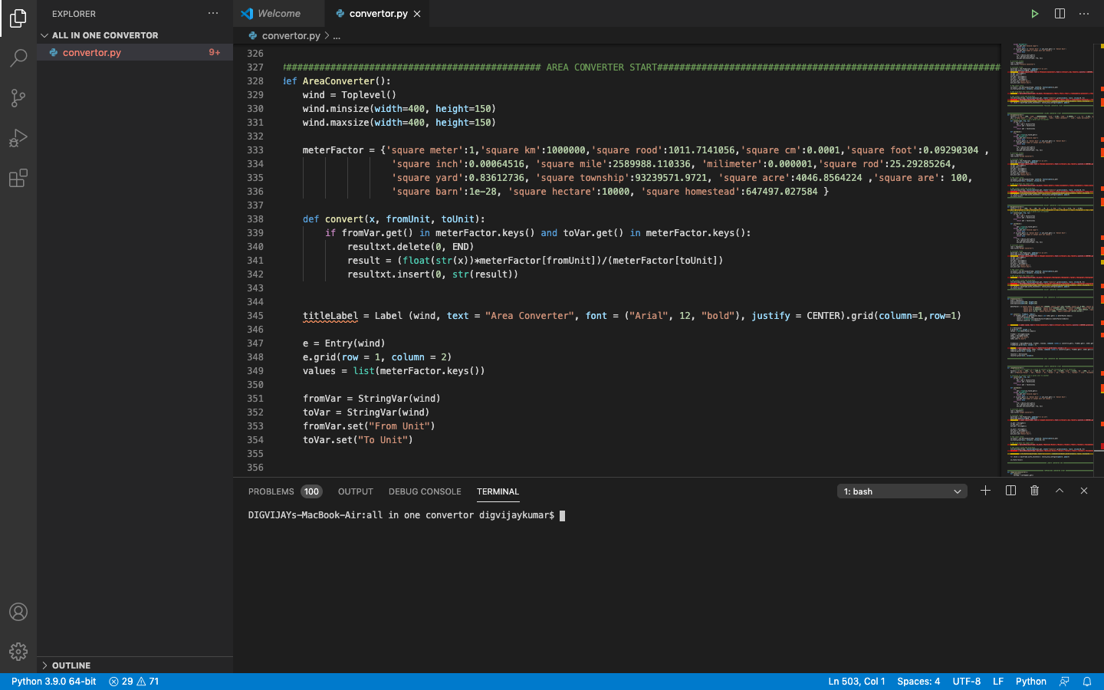

*############################################### LENGTH CONVERTER START ########################################################################*

**def** LengthConverter():

*# factors to multiply to a value to convert from the following units to meters(m)*

factors = {'nmi' : 1852, 'mi' : 1609.34, 'yd' : 0.9144, 'ft' : 0.3048, 'inch' : 0.0254, 'km' : 1000, 'm' : 1, 'cm' : 0.01, 'mm' : 0.001}

ids = {"Nautical Miles" : 'nmi', "Miles" : 'mi', "Yards" : 'yd', "Feet" : 'ft', "Inches" : 'inch', "Kilometers" : 'km', "meters" : 'm', "centimeters" : 'cm', "millileters" : 'mm'}

*# function to convert from a given unit to another*

**def** convert(amt, frm, to):

**if** frm != 'm':

amt = amt * factors[frm]

**return** amt / factors[to]

**else**:

**return** amt / factors[to]

**def** callback():

**try**:

amt = float(in_field.get())

**except** ValueError:

out_amt.set('Invalid input')

**return** **None**

**if** in_unit.get() == 'Select Unit' **or** out_unit.get() == 'Select Unit':

out_amt.set('Input or output unit not chosen')

**return** **None**

**else**:

frm = ids[in_unit.get()]

to = ids[out_unit.get()]

out_amt.set(convert(amt, frm, to))

*# initiate window*

root = Toplevel()

root.title("Length Converter")

*# initiate frame*

mainframe = ttk.Frame(root, padding="3 3 12 12")

mainframe.pack(fill=BOTH, expand=1)

titleLabel = Label (mainframe, text = "Length Converter", font = ("Arial", 12, "bold"), justify = CENTER).grid(column=1,row=1)

in_amt = StringVar()

in_amt.set('0')

out_amt = StringVar()

in_unit = StringVar()

out_unit = StringVar()

in_unit.set('Select Unit')

out_unit.set('Select Unit')

*# Add input field*

in_field = ttk.Entry(mainframe, width=20, textvariable=in_amt)

in_field.grid(row=1, column=2, sticky=(W, E))

*# Add drop-down for input unit*

in_select = OptionMenu(mainframe, in_unit, "Nautical Miles", "Miles", "Yards", "Feet", "Inches", "Kilometers", "meters", "centimeters", "millileters").grid(column=3, row=1, sticky=W)

*# Add output field and drop-down*

ttk.Entry(mainframe, textvariable=out_amt, state="readonly").grid(column=2, row=3, sticky=(W, E))

in_select = OptionMenu(mainframe, out_unit, "Nautical Miles", "Miles", "Yards", "Feet", "Inches", "Kilometers", "meters", "centimeters", "millileters").grid(column=3, row=3, sticky=W)

calc_button = ttk.Button(mainframe, text="Calculate", command=callback).grid(column=2, row=2, sticky=E)

**for** child **in** mainframe.winfo_children(): child.grid_configure(padx=5, pady=5)

in_field.focus()

*################################################### LENGTH CONVERTER END ###########################################################################*

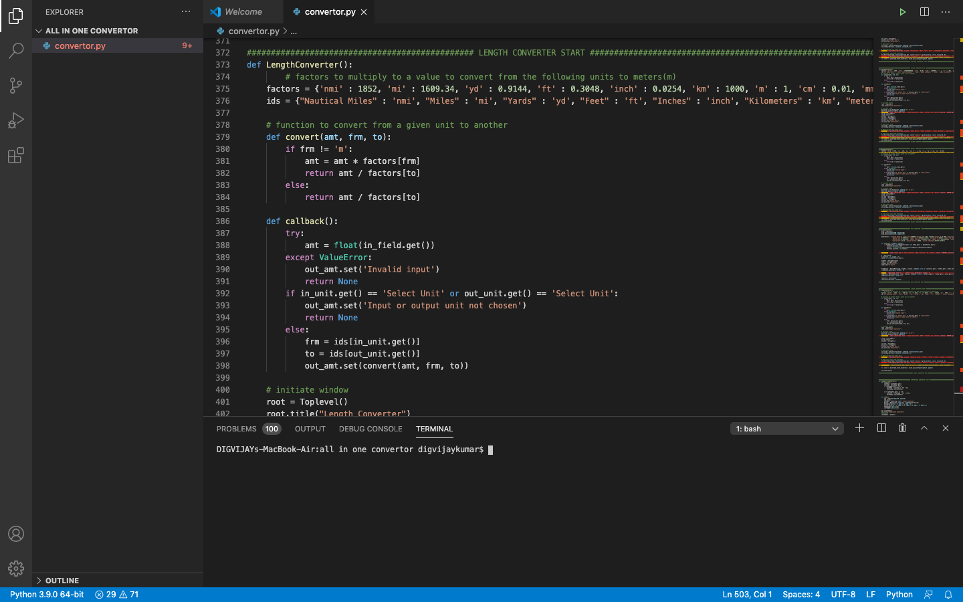

*############################################### TEMPERATURE CONVERTER START ########################################################################*

**def** TemperatureConverter():

**def** convert():

celTemp = celTempVar.get()

fahTemp = fahTempVar.get()

**if** celTempVar.get() != 0.0:

celToFah = (celTemp * 9/5 + 32)

fahTempVar.set(celToFah)

**elif** fahTempVar.get() != 0.0:

fahToCel = ((fahTemp - 32) * (5/9))

celTempVar.set(fahToCel)

**def** reset():

top = Toplevel(padx=50, pady=50)

top.grid()

message = Label(top, text = "Reset Complete")

button = Button(top, text="OK", command=top.destroy)

message.grid(row = 0, padx = 5, pady = 5)

button.grid(row = 1, ipadx = 10, ipady = 10, padx = 5, pady = 5)

fahTempVar.set(int(0))

celTempVar.set(int(0))

top = Toplevel()

top.title("Temperature Converter")

*###MAIN###*

celTempVar = IntVar()

celTempVar.set(int(0))

fahTempVar = IntVar()

fahTempVar.set(int(0))

titleLabel = Label (top, text = "Temperature Converter", font = ("Arial", 12, "bold"), justify = CENTER).grid(column=1,row=1)

celLabel = Label (top, text = "Celcius: ", font = ("Arial", 14), fg = "black")

celLabel.grid(row = 2, column = 1, pady = 10, sticky = NW)

fahLabel = Label (top, text = "Fahrenheit: ", font = ("Arial", 14), fg = "black")

fahLabel.grid(row = 3, column = 1, pady = 10, sticky = NW)

celEntry = Entry (top, width = 10, bd = 5, textvariable = celTempVar)

celEntry.grid(row = 2, column = 1, pady = 10, sticky = NW, padx = 125 )

fahEntry = Entry (top, width = 10, bd = 5, textvariable = fahTempVar)

fahEntry.grid(row = 3, column = 1, pady = 10, sticky = NW, padx = 125 )

convertButton =Button (top, text = "Convert", font = ("Arial", 8, "bold"), relief = RAISED, bd=5, justify = CENTER, highlightbackground = "red", overrelief = GROOVE, activebackground = "green", activeforeground="blue", command = convert)

convertButton.grid(row = 4, column = 1, ipady = 8, ipadx = 12, pady = 5, sticky = NW, padx = 55)

resetButton = Button (top, text = "Reset", font = ("Arial", 8, "bold"), relief = RAISED, bd=5, justify = CENTER, highlightbackground = "red", overrelief = GROOVE, activebackground = "green", activeforeground="blue", command = reset)

resetButton.grid(row = 4, column = 2,ipady = 8, ipadx = 12, pady = 5, sticky = NW)

*############################################### TEMPERATURE CONVERTER END ########################################################################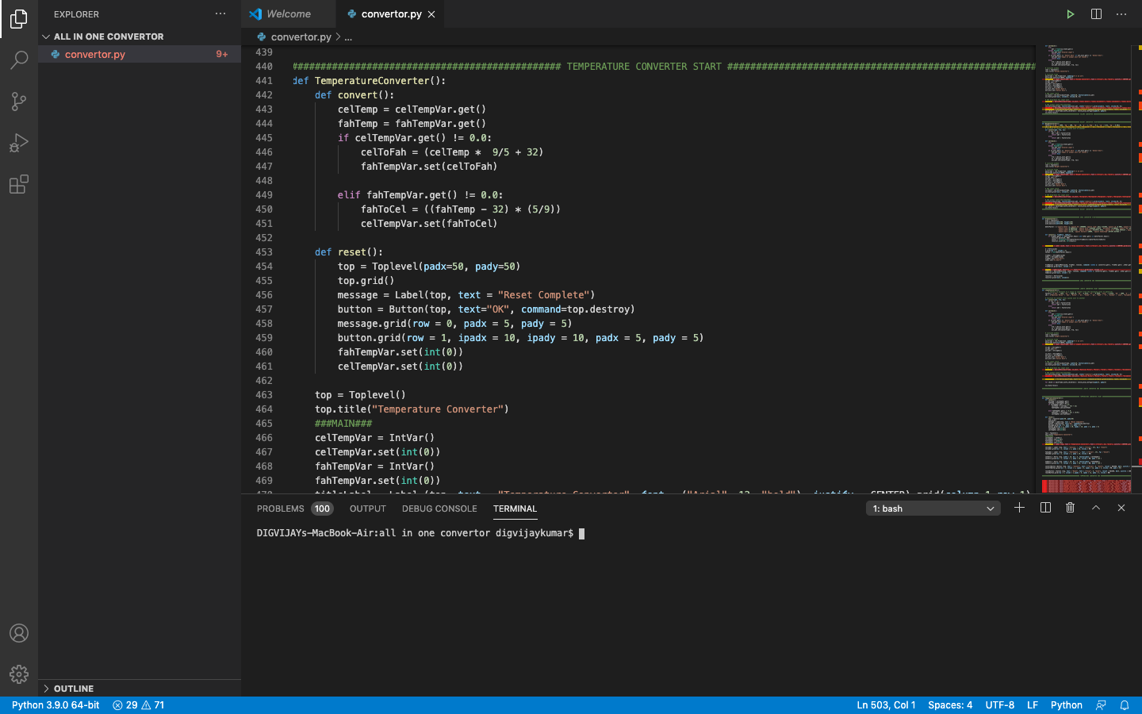*

widget = Button(root, text="Temperature converter", bg="white" , fg="black",font = ("Arial", 12, "bold"), relief = RAISED, bd=5, justify = CENTER, highlightbackground = "red", overrelief = GROOVE, activebackground = "green", activeforeground="blue", command=TemperatureConverter).place(x=170,y=80)

widget = Button(root, text="Length Converter", bg="white" , fg="black",font = ("Arial", 12, "bold"), relief = RAISED, bd=5, justify = CENTER, highlightbackground = "red", overrelief = GROOVE, activebackground = "green", activeforeground="blue", command=LengthConverter).place(x=190,y=140)

widget = Button(root, text="Area Converter", bg="white" , fg="black",font = ("Arial", 12, "bold"), relief = RAISED, bd=5, justify = CENTER, highlightbackground = "red", overrelief = GROOVE, activebackground = "green", activeforeground="blue", command=AreaConverter).place(x=197,y=200)

widget = Button(root, text="Weight Converter", bg="white" , fg="black",font = ("Arial", 12, "bold"), relief = RAISED, bd=5, justify = CENTER, highlightbackground = "red", overrelief = GROOVE, activebackground = "green", activeforeground="blue", command=WeightConverter).place(x=190,y=260)

widget = Button(root, text="Speed Converter", bg="white" , fg="black",font = ("Arial", 12, "bold"), relief = RAISED, bd=5, justify = CENTER, highlightbackground = "red", overrelief = GROOVE, activebackground = "green", activeforeground="blue", command=SpeedConverter).place(x=192,y=320)

widget = Button(root, text="Volume Converter", bg="white" , fg="black",font = ("Arial", 12, "bold"), relief = RAISED, bd=5, justify = CENTER, highlightbackground = "red", overrelief = GROOVE, activebackground = "green", activeforeground="blue", command=VolumeConverter).place(x=190,y=380)

widget = Button(root, text="Power Converter", bg="white" , fg="black",font = ("Arial", 12, "bold"), relief = RAISED, bd=5, justify = CENTER, highlightbackground = "red", overrelief = GROOVE, activebackground = "green", activeforeground="blue", command=PowerConverter).place(x=192,y=440)

widget = Button(root, text="Pressure Converter", bg="white" , fg="black",font = ("Arial", 12, "bold"), relief = RAISED, bd=5, justify = CENTER, highlightbackground = "red", overrelief = GROOVE, activebackground = "green", activeforeground="blue", command=PressureConverter).place(x=182,y=500)

root.mainloop()

**Output Analysis (screenshots)**

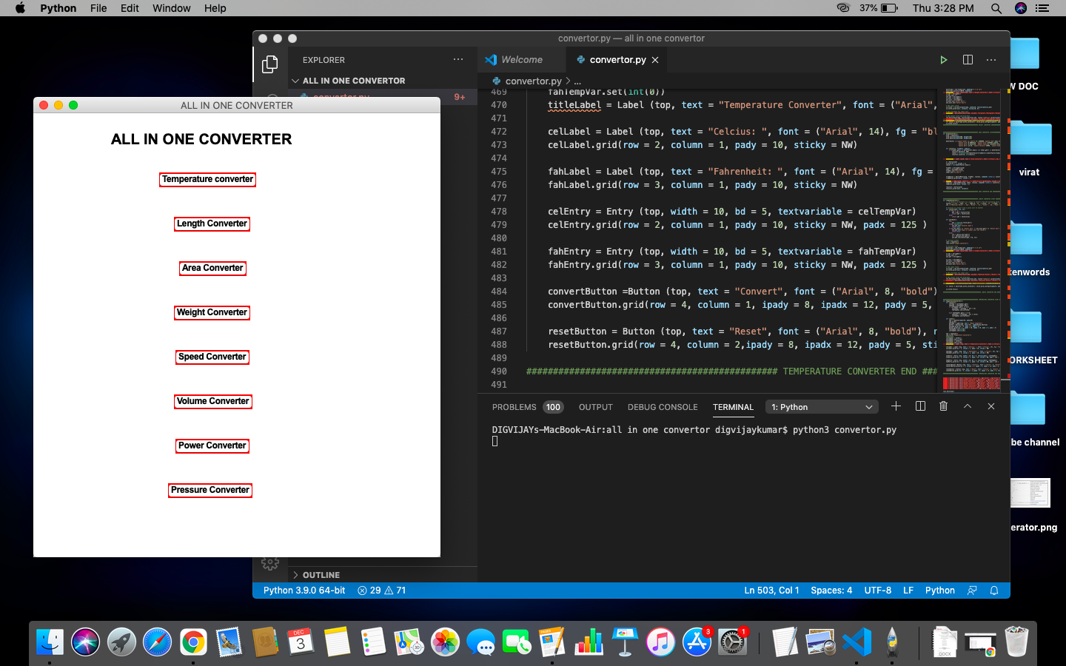

**Here we convert 5 feet into 60 inches through length convertor. Similarly we can convert other quantities.**

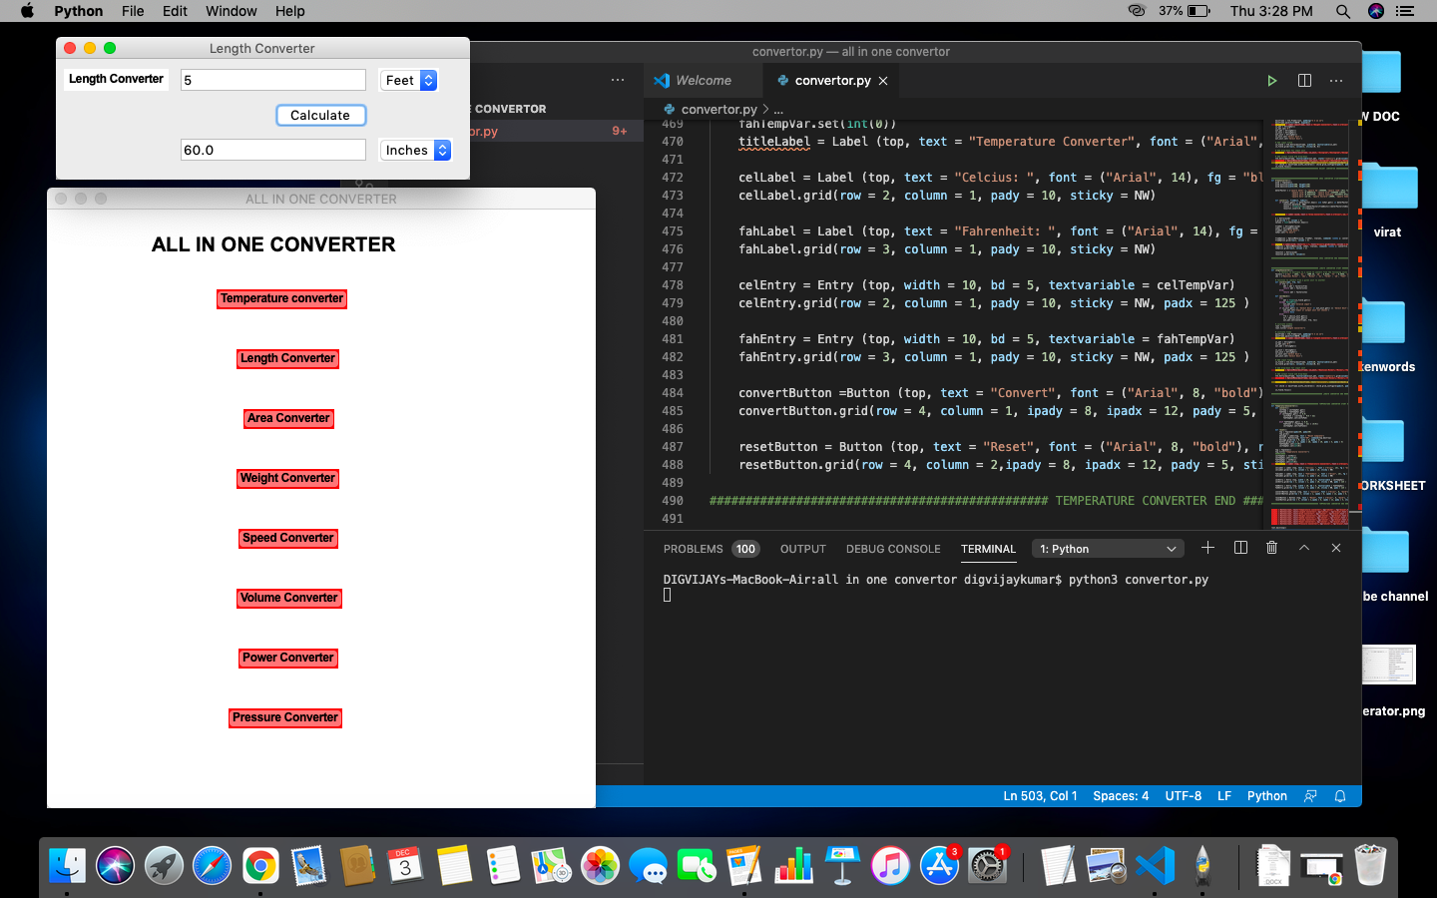

**THANK YOU**